**DOCUMENTATION FOR THE USED CAR LISTING REPORT**

The dataset was gotten from Kaggle using this link <https://www.kaggle.com/datasets/adityadesai13/used-car-dataset-ford-and-mercerdes>

The dataset was in 13 files which represented different car manufacturers of some used cars, 11 of which were cleaned and 2 uncleaned. The files were put in a folder and imported into Power Bi via folder connector after which they were combined and transformed. The files containing the uncleaned datasets were filtered out to avoid duplicates since the cleaned files were available.

Further cleaning and transformations were done including but not limited to filtering rows, renaming columns. adding columns, replacing values and removing blanks.

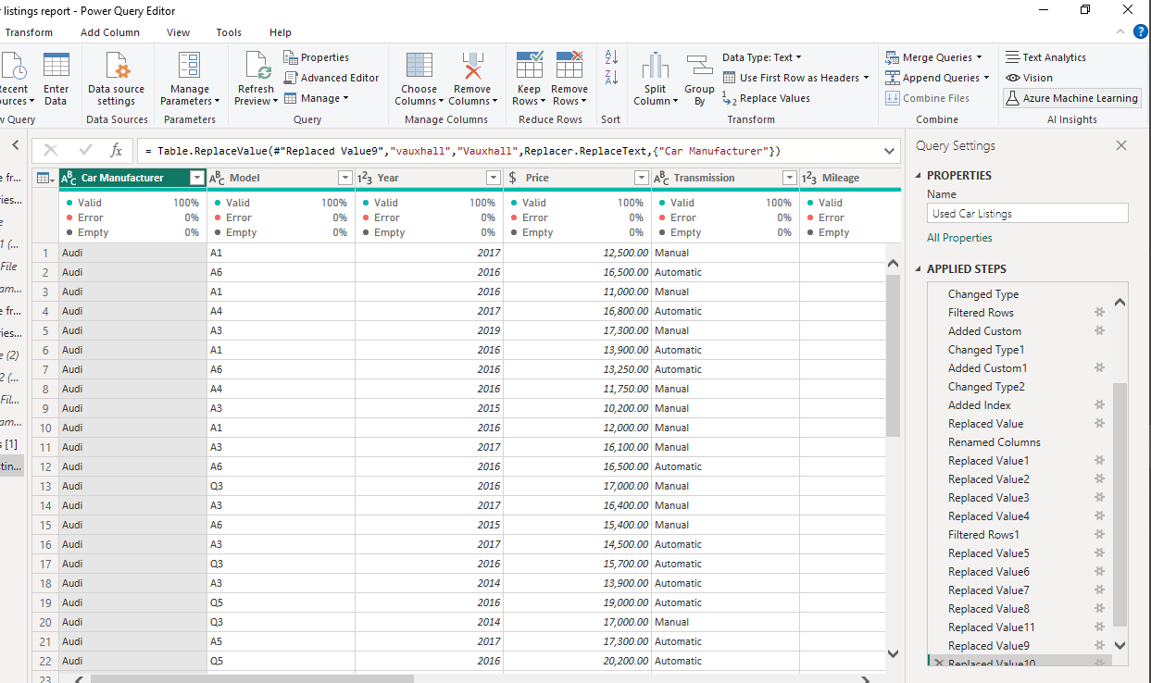

The cleaned data has 13 columns and 108540 rows without errors or blank cells. Then I then closed and applied for onward drawing of insights, visualization, and building of the 5-paged report.

For the visualization, I wrote some DAX functions in finding the average price for each car brand, and average price for all the cars on sale. Page 1 is below.

